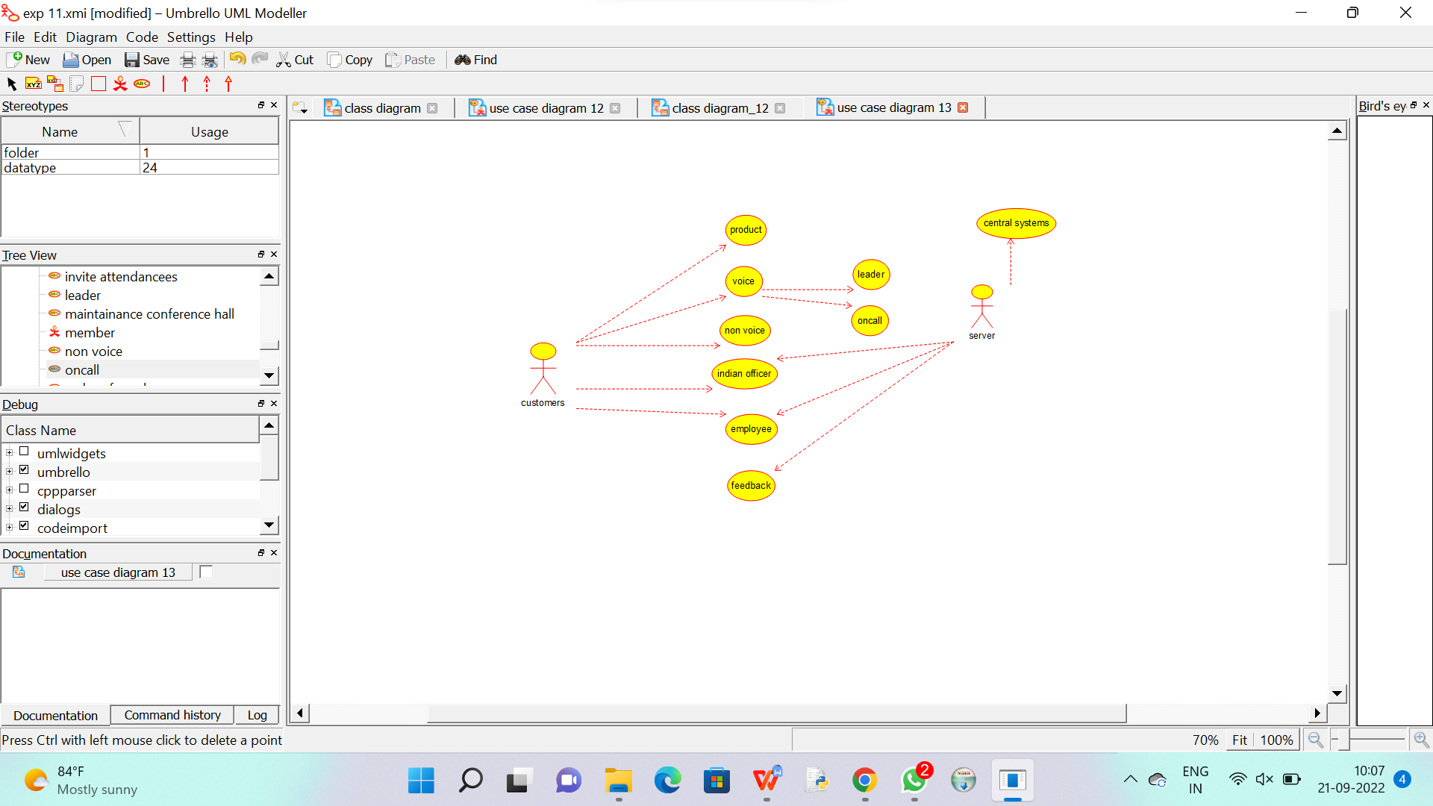

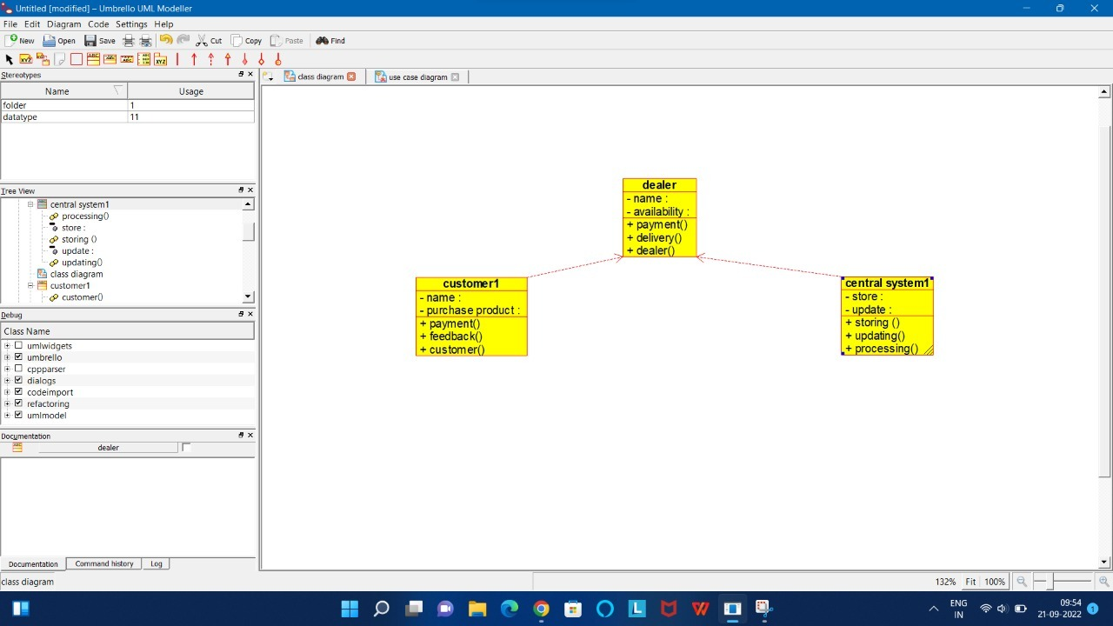

Code for dealer :

/**

 * Class dealer

 */

public class dealer {

  //

  // Fields

  //

  private void name;

  private void availability;

  //

  // Constructors

  //

  public dealer () { };

  //

  // Methods

  //

  //

  // Accessor methods

  //

  /**

   * Set the value of name

   * @param newVar the new value of name

   */

  private void setName (void newVar) {

    name = newVar;

  }

  /**

   * Get the value of name

   * @return the value of name

   */

  private void getName () {

    return name;

  }

  /**

   * Set the value of availability

   * @param newVar the new value of availability

   */

  private void setAvailability (void newVar) {

    availability = newVar;

  }

  /**

   * Get the value of availability

   * @return the value of availability

   */

  private void getAvailability () {

    return availability;

  }

  //

  // Other methods

  //

  /**

   */

  public void payment()

  {

  }

  /**

   */

  public void delivery()

  {

  }

  /**

   */

  public void dealer()

  {

  }

}

Code for new class :

/**

 * Class new_class

 */

public class new_class {

  //

  // Fields

  //

  //

  // Constructors

  //

  public new_class () { };

  //

  // Methods

  //

  //

  // Accessor methods

  //

  //

  // Other methods

  //

}

Code for supplier :

/**

 * Class supplier

 */

public class supplier {

  //

  // Fields

  //

  private void product_supply;

  private void money_transfer_;

  private void available_product_;

  //

  // Constructors

  //

  public supplier () { };

  //

  // Methods

  //

  //

  // Accessor methods

  //

  /**

   * Set the value of product_supply

   * @param newVar the new value of product_supply

   */

  private void setProduct_supply (void newVar) {

    product_supply = newVar;

  }

  /**

   * Get the value of product_supply

   * @return the value of product_supply

   */

  private void getProduct_supply () {

    return product_supply;

  }

  /**

   * Set the value of money_transfer_

   * @param newVar the new value of money_transfer_

   */

  private void setMoney_transfer_ (void newVar) {

    money_transfer_ = newVar;

  }

  /**

   * Get the value of money_transfer_

   * @return the value of money_transfer_

   */

  private void getMoney_transfer_ () {

    return money_transfer_;

  }

  /**

   * Set the value of available_product_

   * @param newVar the new value of available_product_

   */

  private void setAvailable_product_ (void newVar) {

    available_product_ = newVar;

  }

  /**

   * Get the value of available_product_

   * @return the value of available_product_

   */

  private void getAvailable_product_ () {

    return available_product_;

  }

  //

  // Other methods

  //

}

Code for member :

/**

 * Class members

 */

public class members {

  //

  // Fields

  //

  private void name;

  private void id;

  private void proof;

  private void presentation_paper_;

  private void winning_prize_;

  private void member;

  //

  // Constructors

  //

  public members () { };

  //

  // Methods

  //

  //

  // Accessor methods

  //

  /**

   * Set the value of name

   * @param newVar the new value of name

   */

  private void setName (void newVar) {

    name = newVar;

  }

  /**

   * Get the value of name

   * @return the value of name

   */

  private void getName () {

    return name;

  }

  /**

   * Set the value of id

   * @param newVar the new value of id

   */

  private void setId (void newVar) {

    id = newVar;

  }

  /**

   * Get the value of id

   * @return the value of id

   */

  private void getId () {

    return id;

  }

  /**

   * Set the value of proof

   * @param newVar the new value of proof

   */

  private void setProof (void newVar) {

    proof = newVar;

  }

  /**

   * Get the value of proof

   * @return the value of proof

   */

  private void getProof () {

    return proof;

  }

  /**

   * Set the value of presentation_paper_

   * @param newVar the new value of presentation_paper_

   */

  private void setPresentation_paper_ (void newVar) {

    presentation_paper_ = newVar;

  }

  /**

   * Get the value of presentation_paper_

   * @return the value of presentation_paper_

   */

  private void getPresentation_paper_ () {

    return presentation_paper_;

  }

  /**

   * Set the value of winning_prize_

   * @param newVar the new value of winning_prize_

   */

  private void setWinning_prize_ (void newVar) {

    winning_prize_ = newVar;

  }

  /**

   * Get the value of winning_prize_

   * @return the value of winning_prize_

   */

  private void getWinning_prize_ () {

    return winning_prize_;

  }

  /**

   * Set the value of member

   * @param newVar the new value of member

   */

  private void setMember (void newVar) {

    member = newVar;

  }

  /**

   * Get the value of member

   * @return the value of member

   */

  private void getMember () {

    return member;

  }

  //

  // Other methods

  //

}